Web Team project Report

Team chap

abstract

This web application "CHAP" can be used to teach lectures (eg HTML, JavaScript, etc.) in the classroom. The lessons that I have purchased for my classroom can be used to create web pages using web editors in web editors and analyze the results in web editors, according to instructions and lessons in the classroom. You can purchase additional coins. The auditorium that purchased my information page, the auditorium in progress, the Han River, and coins.

Problem specification

Web application topics are online education training sites. Click on the shortcut on this homepage and run it. Follow the instructions and instructions for scheduling lectures so that you can learn the languages ​​in which you will be able to teach, and if you write the code at the same time, the results will be displayed immediately. For example, "Hello World" prints "System.out.println (args)". With results. Install a separate development environment on the web.

In addition, the entire design will allow us to design our design by expanding our creative design further.

Competent Notices and Accused Missiles SW education is required for elementary school students in 2018. Of course, you can not use your account because there is no reason to excuse it. Now you can program using blog / site. I want to learn how to write hanging with the main character. Elementary student Yi Soon Beginners can easily learn the programming language by hand. shout.

Anyone who adds later and provides the desired functionality will provide a platform. Current training sites use courses. More things are needed to learn more. For example, if you want to teach a time at a university, you can easily understand it with your seniors.

Web Application Design and Implementation

MainPage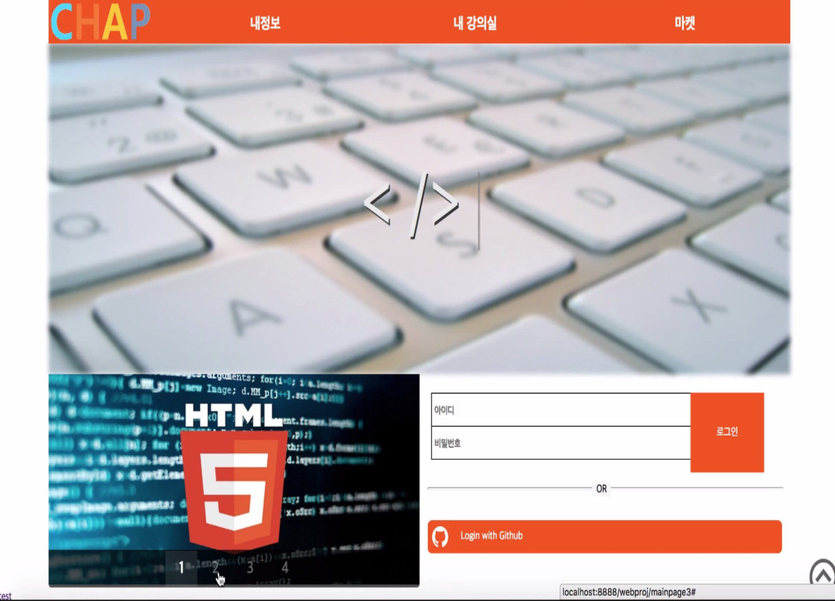

Side Bar

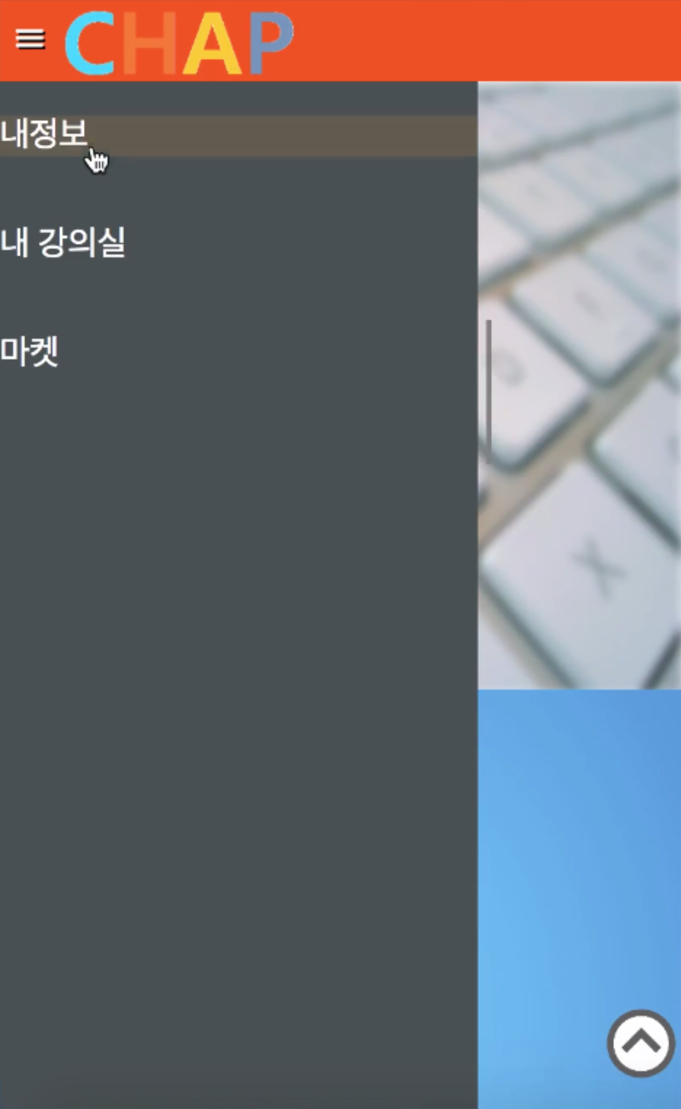

React Web

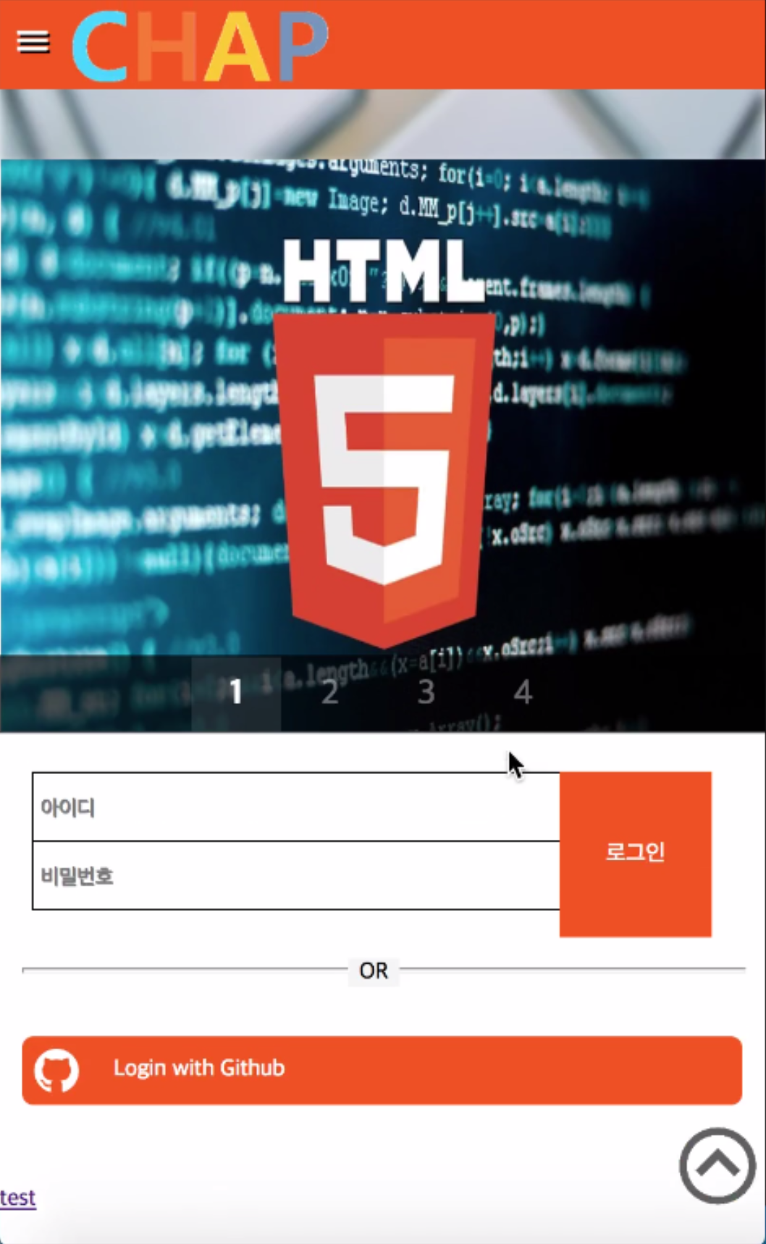

Study Page

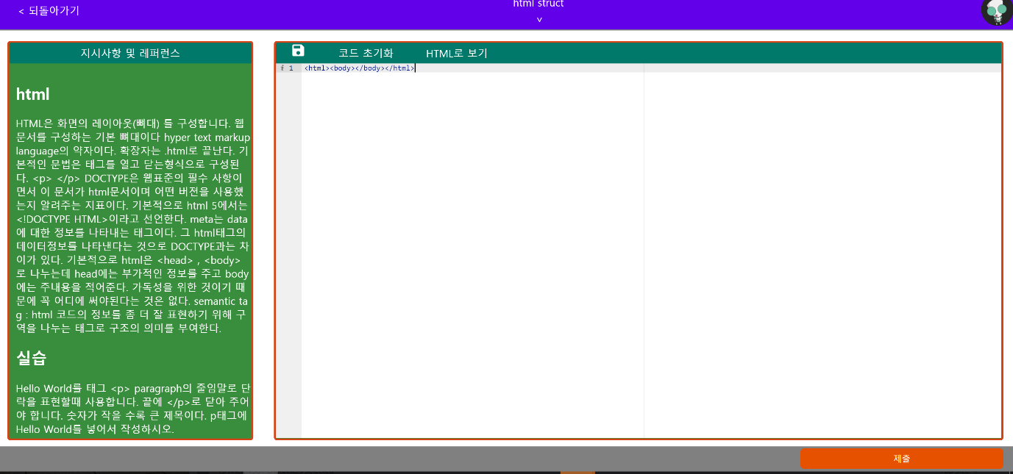

Conclusion

With our web application, you can lower the barriers to entry-level learners, check your coding skills, or inform more people about your coding in talent donation format. As more and more software compulsory education is being implemented, there is a growing interest and need for more people. Also, if you are studying alone with multiple content and an effective study system, you will be able to easily code with interest. In conclusion, our web application is a website that is easy to understand and introductory to those who do not know coding or want to start.